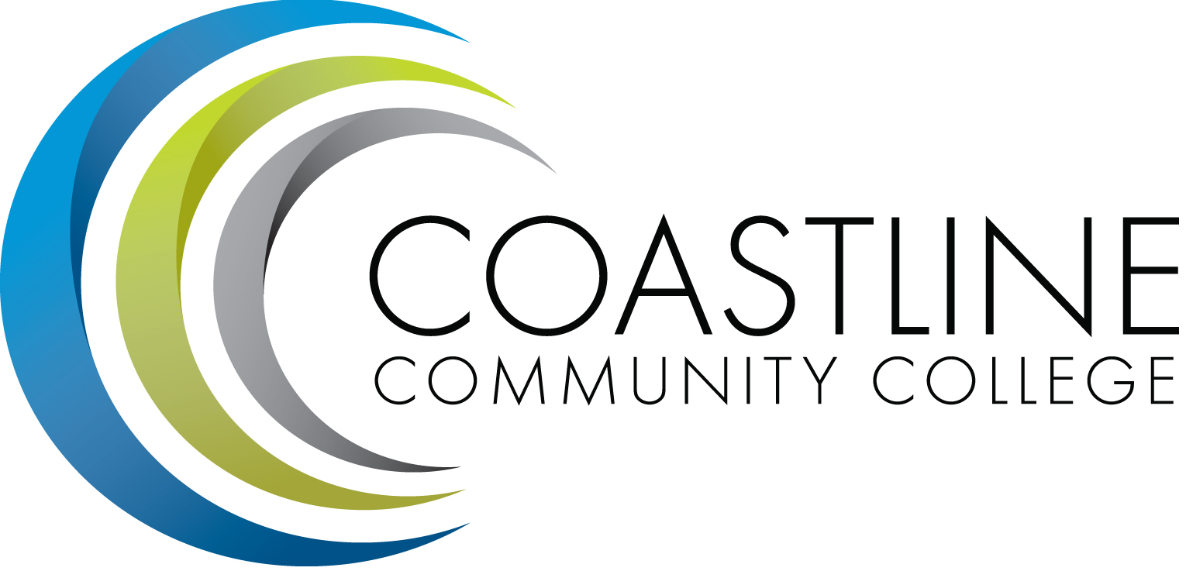
Coastline Management Meeting (CMT) Agenda
January 16, 2018, 9:00 – 11:00 a.m.
College Center – 4th Floor Conference Room

Committee Mandate: To review and improve College operations and management through sharing information, discussion, and staff development.

CALL TO ORDER
  - Welcome
  - Adoption of Agenda
  - Approval of Minutes: December 5, 2017

SPECIAL REPORTS

ACTION ITEMS
  - Follow up on Action Items from December 5, 2017:
    - Judy Garvey will prepare a press release on Cyber-attack video game.

STANDING REPORTS
  - Accreditation – V. Rodriguez
  - PIEAC – S. Barnes, V. Rodriguez
  - Budget – C. Nguyen
  - Academic Senate – S. Barnes
  - Classified Senate – K. Donahue
  - Associated Student Government – N. Brais
  - Institutional Effectiveness – A. Zentner
  - Executive Team – J. Groot, K. Mueller, C. Nguyen, V. Rodriguez
  - President’s Report – L. Adrian
  - HR Report – R. Akins
  - Financial Aid Federal Program Review Update

DISCUSSION ITEMS
  - Familiarization with the Integrated Planning Guide/Ideas for Providing Information to Others – L. Adrian
  - Guided Pathways Follow Up to 11/20-21 Meetings
  - Retreat Planning
    - Appreciative Inquiry
    - Emotional Intelligence
    - Planning for 2018-19

HOT TOPICS

ANNOUNCEMENTS

ADJOURNMENT

CDMA – Closed Session

Next Meeting: ___________, 2018
*Attachment has been emailed.
**Attachment available at meeting.

